



**Department of Computer Science & Engineering**

Course Titel: Software Development Lab

Course Code : CSE-136

Project Report : Phonebook Application

|  |  |
| --- | --- |
| **Submitted By** | **Submitted To** |
| Name : MD Safwan Neshat Rangan  ID : 221311089  Session : Fall-2022  Semester : 3rd  Batch : 29th | Samira Tareque  Lecturer (provisional)  Varendra University  Department of CSE |

Introduction:

My project is about “Phonebook Application”.This project will give you a basic concept over how to make a Phonebook application. It is a well Organized. The project is simple to understand and use.It is build without any graphical design.

Programming Language : C language.

Advantages:

1. Add a new Contact:

In this feature, user can add a new Contract record which should contain name, address, number, email. Thus, given information is stored in file.

2.List all Contacts:

In Phonebook application project, user can get a list of all contact records in a file. By this feature.

3.Search for contact:

In Phonebook application project, searching contact records are one of the most useful featuresin this application. usar can find a contract by this feature.

4.Edit a Contact:

In this mini project, editing contact are one of the most useful features. User can search and edit record through contact name. it can make this application data up to date .

5.Delete a Contact:

This feature allows user to delete added record of any contact information. For this the contact name to be removed need to be provided. To delete the record, press ‘Enter’ and the respective contact will be deleted from the file.

Limitation of this project:

1.Too many options can make simple event schedule complicated.

2.Data corruption is possible.

3.Dependent on technology.

Flowchart of The Application:

Main Menu

1. Add a New Contact

2. List all Contacts

3. Search for contact

4. Edit a Contact

5. Delete a Contact

List all Contacts

0. Exit

End

Exit

Name of Contact :

Or

Mobile Number :

Exit

Exit

Name of Contact:

Search for contact

Delete a Contact

Exit

Exit

Email

Address

Name

Phone

Add a New Contact

Screenshot of Application:

0 .Main Menu:

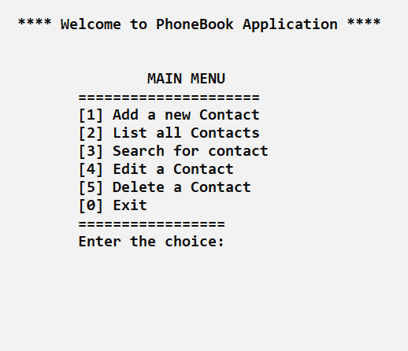

1.Add a new contact:

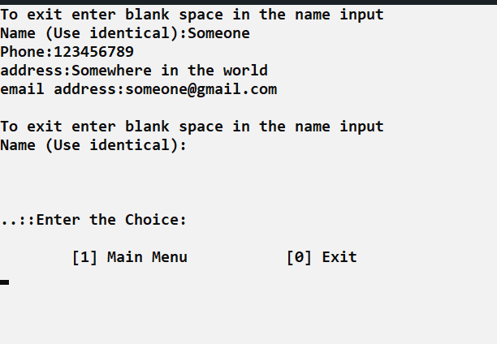

2.List all contacts:

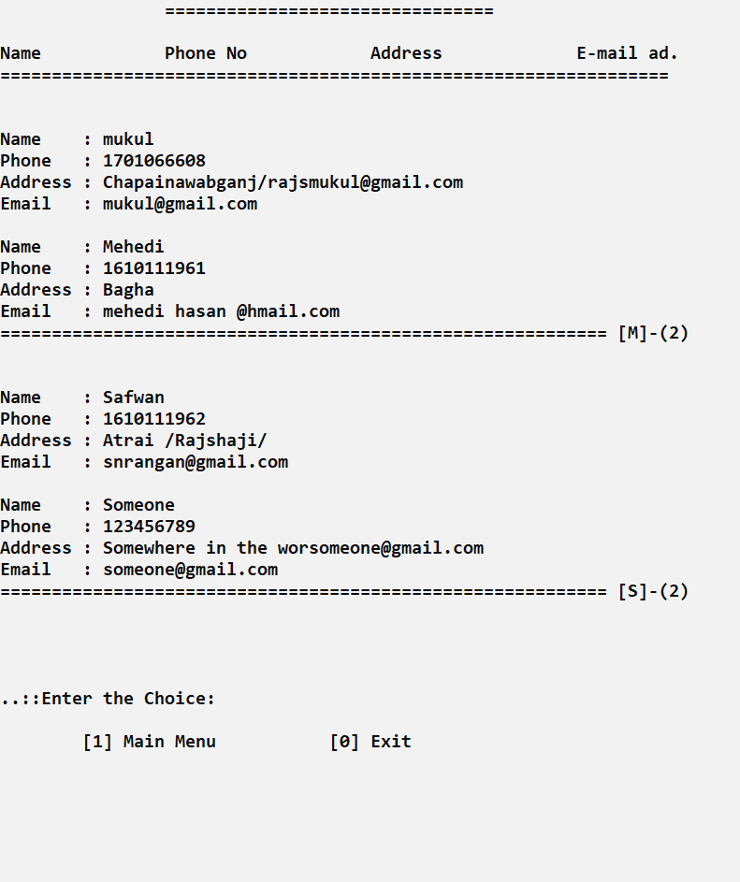

3.Search For contact:

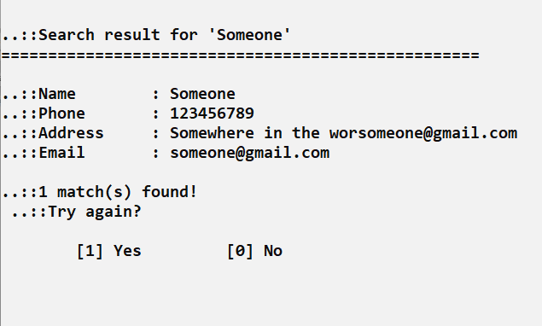

4.Edit a contact:

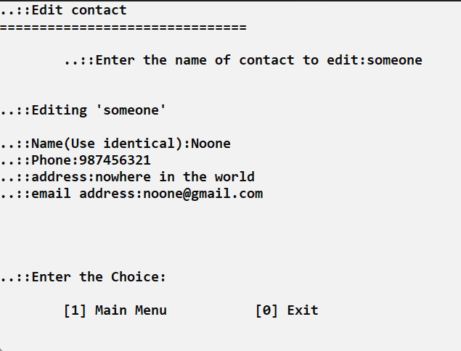

5.Delete a contact:

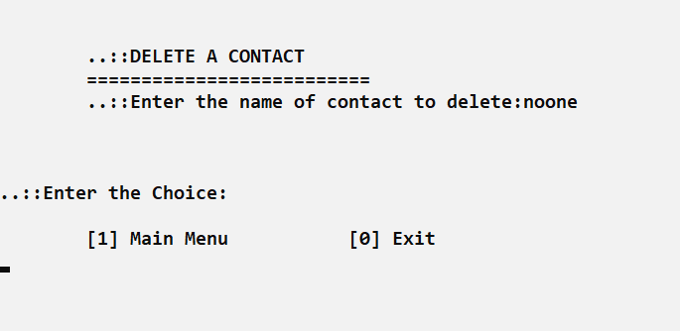

Conclusion:

We use Phonebook in our everyday life.This Phonebook helps us to find important Contracts and address easily.